Android Quickstart Guide

Download Eclipse:

- Go to http://www.eclipse.org/helios/ and download eclipse. I'm not sure if the latest Eclipse can run the ADT plugin or not, so just download the officially supported version of Eclipse, helios.
- Click on the Downloads tab.
- Click on the Eclipse Classic 3.7.2 link and choose your OS.

Download ADT plugin:

- Once you have Eclipse installed, open it up and go to Help → Install New Software.
- In the work with field, add this: https://dl-ssl.google.com/android/eclipse/
- You should see Developer's Tools. Install that. That should come with the necessary android stuff you need to work on the project.

Download 1.6 SDK:

- Since our project is using the 1.6 SDK (to support really old phones) you need to make sure you have it. Open up the Android SDK Manager, which you can do from within Eclipse.
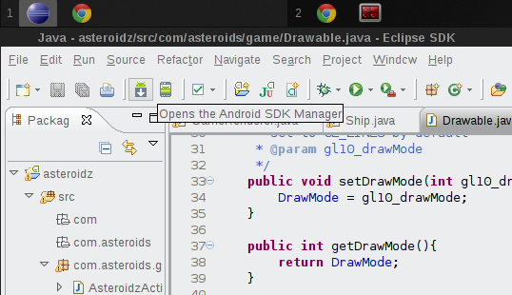
- Look for Android 1.6 (API 4) and install that.
- That's it! You should have everything you need to work on the project! Follow the SVN tutorial to checkout the project and start working on it.

